ICT01 – FLIGHT MANAGEMENT
Description
Instruction:
1.if you are using TLAB**, Sample compile and run JCL is available in "TLABADM.LAB.SYS.COMPRUN". Please go in view mode and copy the members to your deliverable dataset.
2. if you are using TLAB**,the IP address is 10.142.149.210 and the Port is 623 to connect to Mainframe Terminal
Please do not EVALUATE and just SUBMIT the code for Evaluation - CC/MOCK/ICT assessments.

Objective:
To create a COBOL-VSAM application to FLIGHT MANAGEMENT.
STEP1: ISPF
1) Allocate the below PDS with the following parameters given below.
- USERID.MYLIB.COBOL.ICT01 - COBOL and JCL Source Program
- USERID.MYLIB.LOADLIB - COBOL Load Module
2) Allocate a PS dataset with a record length of 80 as per the naming conventions given below.
- INPUT PS1- USERID.MYDATA.ICT01.PS1
- RECORD LENGTH (80,80)
- Enter 1st row in PS file. 1st row contains header details for reference.
- Enter 2nd row in PS file. 2nd row contains layout details for reference
- All alphanumeric data to be entered in CAPITAL letters.

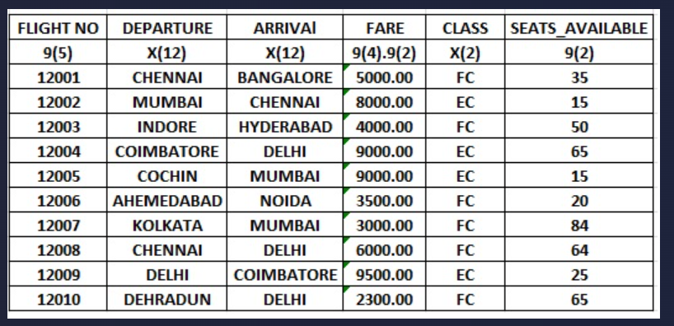

1) Allocate a PS dataset with a record length of 80 as per the naming conventions given below.
- INPUT PS2- USERID.MYDATA.ICT01.PS2
- RECORD LENGTH (80,80)
- Do not enter 1st row in PS file. 1st row contains header details for reference.
- Do not enter 2nd row in PS file. 2nd row contains layout details for reference
- All alphanumeric data to be entered in CAPITAL letters.
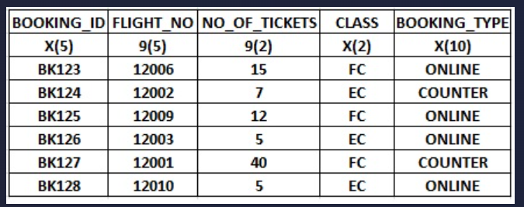

STEP2: JCL
1) Create a member ICT01J01 in USERID.MYLIB.COBOL.ICT01 and write a JCL to perform the below task.
- STEP01 : Pre delete dataset USERID.MYDATA.ICT01.PS3
- STEP02: Allocate a PS dataset with a record length of 80 as per the naming conventions given below.
DATASET NAME - USERID.MYDATA.ICT01.PS3
RECORD LENGTH (80,80)
- STEP03 : Use SORT utility to perform the below operation on PS1 dataset and store the output in PS3 dataset
Remove the header record
Remove the layout details
Sort records in ascending order based on Flight_No

2) Create a member ICT01J02 in USERID.MYLIB.COBOL.ICT01 and write a JCL to perform the below task.
- STEP01 : Pre delete dataset USERID.MYDATA.ICT01.KSDS
- STEP02: Allocate a KSDS dataset with the following naming conventions.
INPUT KSDS - USERID.MYDATA.ICT01.KSDS
RECORD LENGTH (80,80)
KEY IS FLIGHT_N0
- STEP03: Load the PS3 dataset into the KSDS .
STEP 3: COBOL .
3) Create a Member name ICT01CBM inside the PDS USERID.MYLIB.COBOL.ICT01 for the Main Program.
i. In the Main Program, Write a COBOL program to perform the following,
Input file 01 to be used in the program : USERID.MYDATA.ICT01.PS2
DD name to be used : INFLIPS1
Input file 02 to be used in the program : USERID.MYDATA.ICT01.KSDS
DD name to be used : INFLIPS2
Output file to be used in the program : USERID.MYDATA.ICT01.PS4
DD name to be used : OUTFLIPS
Note: Please use only the above mentioned DD names. Do not use COPYBOOKs for declaring input or output file layout in COBOL program.
ii. Read all the records from INPUT PS2 and validate input data for each field in the input file.
i. Check whether the BOOKING_ID contains 5 digits
ii. Check whether the FLIGHT_NUMBER is NUMERIC
iii. Check whether the NO_OF_TICKETS contains numbers less than 50
iv. Check whether the CLASS contains either FC or EC.
v. Skip the input record which fails in the validation and process the next record.
iii.Perform the below task for the records which has passed through the validation
i. Read the flight (DEPARTURE, ARRIVAL, FARE, CLASS,SEATS_AVAILABLE) from the KSDS by using FLIGHT_NO as key
ii. Check whether CLASS in PS2 is equal to CLASS in KSDS ,
iii. IF PS2 CLASS = KSDS CLASS, then
Calculate TOTAL_FARE = NO_OF_TICKETS * FARE
iv. IF PS2 CLASS != KSDS CLASS, then
Calculate TOTAL_FARE = 0.0
iv. Add 100 to the TOTAL_FARE , if the BOOKING_TYPE is ONLINE
v. Load the FLIGHT_NO , TOTAL_FARE, NO_OF_TICKETS, SEATS_AVAILABLE , DEPARTURE, ARRIVAL , CLASS into 1 dimensional COBOL table.
vi. Read the table to calculate the STATUS
If NO_OF_TICKETS <= SEATS_AVAILABLE
THEN STATUS = CONFIRMED
If NO_OF_TICKETS > SEATS_AVAILABLE
THEN STATUS = NOT CONFIRMED
vii. Write the records in the output file USERID.MYDATA.ICT01.PS4 as per the output layout.
OUTPUT LAYOUT:
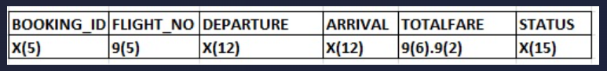
NOTE: One space filler is to be inserted between each field.
INSTRUCTIONS:
- Follow the proper coding standards
- Provide proper error handling routines.
EXPECTED DELIVERABLES
- PS1 - INPUT DATASET
- PS2 - INPUT DATASET
- PS3 & PS4 - OUTPUT DATASET
- JCL PROGRAM
- COBOL PROGRAM
- RUN JCL
Evaluation Procedure:
1) Use your run JCL to compile the Program and test your program with the necessary inputs and make sure you get the return code MAXCC 00 before submitting it for Evaluation.
2) Download your dataset (USERID.MYLIB.ICT01 (ICT01CBM), (ICTJCL01), (ICTJCL02), USERID.MYDATA.ICT01.PS1 and USERID.MYDATA.ICT01.PS2 to your system and name the file ICT01COBM.txt, ICT01JCL01.txt, ICT01JCL02.txt, ICT01INP1.txt and ICT01INP2.txt
3) Download your output dataset USERID.MYDATA.ICT01.PS3 and USERID.MYDATA.ICT01.PS4 to your system and name the file ICT01OUT1.txt and ICT01OUT2.txt
4) Download your run JCL with the necessary inputs as per the QB Requirement and name it RUNJCL.txt
5) Drag the file into the code Editor.
6) Then Press the Evaluate button for Evaluation.

